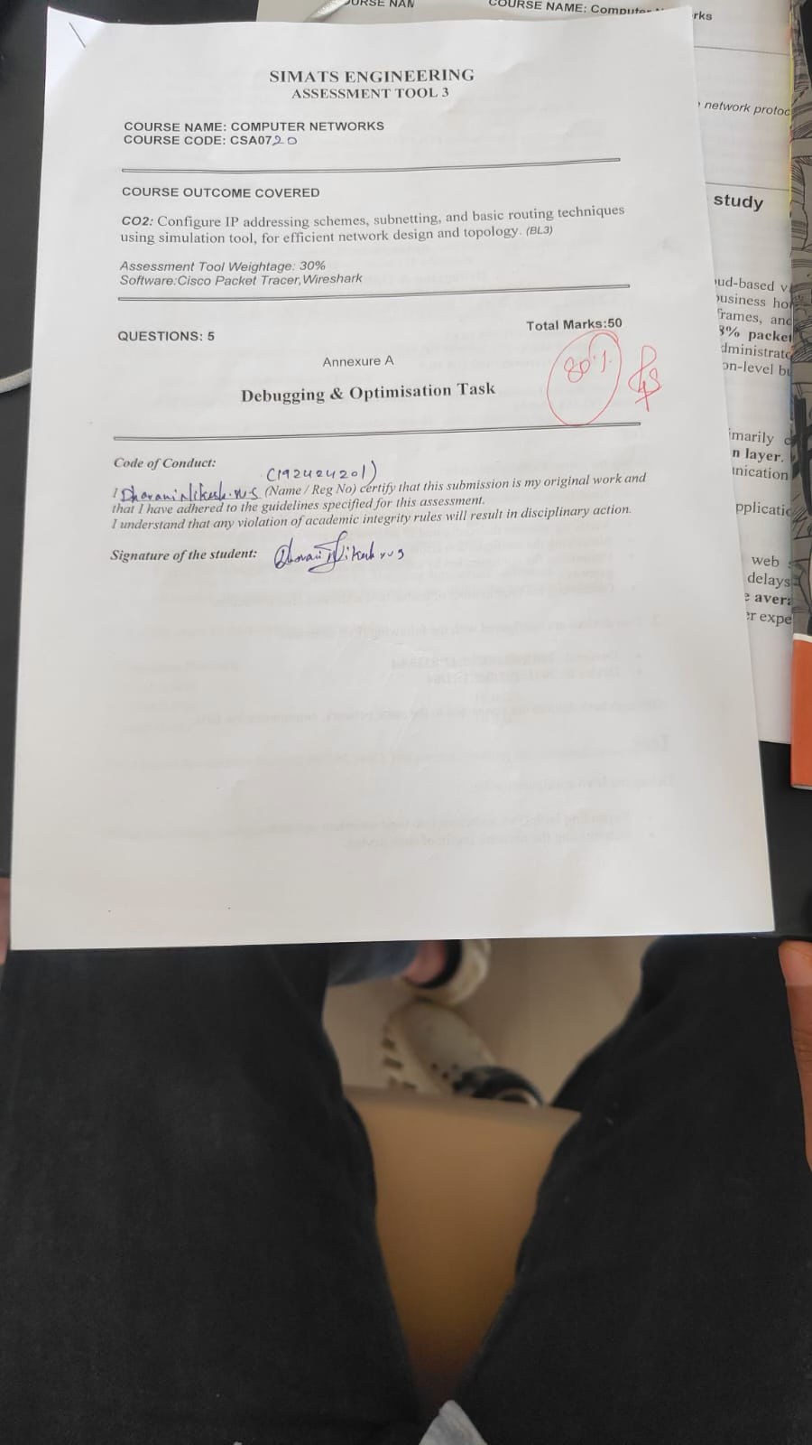

Annexure A

Debugging & Optimisation Task
1. A network administrator has configured a workstation with the following settings:
- IP Address: 192.168.10.65
- Subnet Mask: 255.255.255.192 (/26)
- Default Gateway: 192.168.10.1
However, the workstation is unable to communicate with other systems configured in the subnet 192.168.10.0/26.
Task
Debug the network configuration by:
- Identifying the subnet to which the configured IP address belongs.
- Determining the network address, broadcast address, and valid host range.
- Verifying whether the configured IP address and gateway are valid.
- Identifying the configuration errors.
- Optimizing the configuration by assigning an appropriate IP address and default gateway.
- Calculating the total number of usable host addresses after correction.
ANSWER:
1. IPv4 Subnet Misconfiguration Debugging
Configured Parameters:
• Workstation IP Address: 192.168.10.65
• Subnet Mask: 255.255.255.192 (/26)
• Default Gateway: 192.168.10.1
• Target Network Subnet: 192.168.10.0/26
Detailed Technical Analysis
1. Subnet & Range Identification: A /26 mask has a block size of 64 addresses (2^(32-26) = 64). For the IP address 192.168.10.65, the network block spans from 192.168.10.64 to 192.168.10.127. The network address is 192.168.10.64, the broadcast address is 192.168.10.127, and the valid host range is 192.168.10.65 – 192.168.10.126.
2. Error Diagnostics: The configured IP address (192.168.10.65) is a valid host address within its subnet. However, the configured default gateway (192.168.10.1) belongs to the adjacent subnet (192.168.10.0/26, range .1–.62). Because the host and gateway reside in different broadcast domains, local ARP requests for the gateway fail or require inter-VLAN routing, breaking communication with other systems on 192.168.10.0/26.
3. Optimization & Correction: To join the target 192.168.10.0/26 subnet alongside gateway 192.168.10.1, reassign the host an available IP in the 192.168.10.1–192.168.10.62 range (e.g., 192.168.10.10). Total usable host addresses in the corrected subnet: 62 hosts (2^6 - 2).
Parameter | Configured (Faulty) | Corrected (Subnet 192.168.10.0/26)
IP Address | 192.168.10.65 | 192.168.10.10 (Valid host)
Subnet Mask | 255.255.255.192 (/26) | 255.255.255.192 (/26)
Network Address | 192.168.10.64 | 192.168.10.0
Broadcast Address | 192.168.10.127 | 192.168.10.63
Valid Host Range | 192.168.10.65 – 192.168.10.126 | 192.168.10.1 – 192.168.10.62
Default Gateway | 192.168.10.1 (Out-of-subnet) | 192.168.10.1 (In-subnet)
Usable Host Capacity | 62 addresses | 62 addresses
2. Two devices are configured with the following IPv6 addresses:
- Device A: 2001:db8::ff00:42:8329/64
- Device B: 2001:db8:0:0:1::1/64
Although both devices are connected to the same network, communication fails.

Task
Debug the IPv6 configuration by:
- Expanding both IPv6 addresses into their complete notation.
- Determining the network prefix of each device.
- Verifying whether both devices belong to the same subnet.
- Identifying the addressing or prefix mismatch.
- Optimizing the IPv6 configuration by assigning appropriate addresses.
- Calculating the number of available host addresses within the corrected subnet.
ANSWER:
2. IPv6 Address Expansion & Connectivity Debugging
Configured IPv6 Addresses:
• Device A: 2001:db8::ff00:42:8329/64
• Device B: 2001:db8:0:0:1::1/64
Expanded Notation & Subnet Comparison
- Address Expansion (128-bit Full Representation):
• Device A: 2001:0db8:0000:0000:0000:ff00:0042:8329/64
• Device B: 2001:0db8:0000:0000:0001:0000:0000:0001/64
2. Prefix & Subnet Evaluation:
• Device A Prefix (First 64 bits): 2001:0db8:0000:0000::/64 (2001:db8:0:0::/64)
• Device B Prefix (First 64 bits): 2001:0db8:0000:0000::/64 (2001:db8:0:0::/64)
• Same Subnet Verification: Yes, both devices share the exact same 64-bit network prefix. There is no IP prefix mismatch.
3. Root Cause Analysis for Failure:
Since IP addressing is mathematically valid and both hosts reside on 2001:db8::/64, communication failure is caused by lower-layer or protocol-level issues:
• Neighbor Discovery Protocol (NDP) Blocked: ICMPv6 Type 135 (NS) and Type 136 (NA) packets are blocked by host firewalls or ACLs.
• VLAN Isolation: Switch ports are assigned to different access VLANs without L2 adjacency.
• Complex Interface Notation: Device B contains '1' in the 5th hextet (part of the 64-bit Interface ID, not the network prefix), which can cause visual confusion during manual setup.
4. Optimization & Capacity:
Simplify addressing using clean sequential interface IDs (e.g., Device A = 2001:db8::1/64, Device B = 2001:db8::2/64). Available host addresses in this /64 subnet: 2^64 = 18,446,744,073,709,551,616 addresses (IPv6 does not use broadcast addresses).
Device | Expanded IPv6 Address (128-bit) | 64-Bit Network Prefix | Recommended Clean IP
Device A | 2001:0db8:0000:0000:0000:ff00:0042:8329 | 2001:db8:0:0::/64 | 2001:db8::1/64
Device B | 2001:0db8:0000:0000:0001:0000:0000:0001 | 2001:db8:0:0::/64 | 2001:db8::2/64
3. An organization has allocated the network 192.168.1.0/24 into several departments using the subnet masks /26, /27, and /28. Some departments report insufficient IP addresses, while others have a large number of unused addresses.
Task
Analyze and optimize the subnet allocation by:
- Identifying the network address, broadcast address, and host range for each subnet.
- Calculating the number of usable and unused IP addresses.
- Identifying inefficient subnet allocations.
- Debugging the addressing plan by locating subnet allocation mistakes.
- Recommending an optimized subnetting scheme using VLSM to improve address utilization while supporting current departmental requirements.

ANSWER:
3. Variable Length Subnet Masking (VLSM) Optimization
Initial Base Network: 192.168.1.0/24 (Total 256 addresses)
Existing Inefficient Allocation Analysis:
Subnet Prefix | Network Address | Broadcast Address | Valid Host Range | Usable Hosts | Efficiency Assessment
/26 | 192.168.1.0 | 192.168.1.63 | 192.168.1.1 – .62 | 62 | High waste if allocated to small team
/27 | 192.168.1.64 | 192.168.1.95 | 192.168.1.65 – .94 | 30 | Adequate for medium team
/28 | 192.168.1.96 | 192.168.1.111 | 192.168.1.97 – .110 | 14 | Risk of address exhaustion

Root Cause & Debugging Analysis
• Flawed Static Allocation: Static mask assignment creates rigid subnet boundaries without considering actual host density. Assigning a /28 (14 usable IPs) to a growing team causes early IP depletion, while assigning a /26 (62 usable IPs) to a small department leaves dozens of IPs permanently unused.
• Discontiguous Allocation Gaps: Arbitrary subnetting without top-down planning leaves unallocated address holes that cannot be aggregated easily.
Recommended VLSM Optimization Plan
To optimize utilization, allocate subnets strictly in descending order of size based on actual host requirements:
Department Needs | Allocated CIDR | Subnet Mask | Network Address | Host Range | Broadcast | Usable Hosts
Dept A (Large: 50 hosts) | /26 | 255.255.255.192 | 192.168.1.0 | .1 – .62 | 192.168.1.63 | 62
Dept B (Medium: 25 hosts) | /27 | 255.255.255.224 | 192.168.1.64 | .65 – .94 | 192.168.1.95 | 30
Dept C (Small: 10 hosts) | /28 | 255.255.255.240 | 192.168.1.96 | .97 – .110 | 192.168.1.111 | 14
Future Expansion / Unused | /25 | 255.255.255.128 | 192.168.1.128 | .129 – .254 | 192.168.1.255 | 126
4. Two devices are configured with the following IPv6 addresses:
- Device A: 2001:db8::ff00:42:8329/64
- Device B: 2001:db8:0:0:1::1/64
Although both devices are connected to the same network, communication fails.
Task
Debug the IPv6 configuration by:
- Expanding both IPv6 addresses into their complete notation.
- Determining the network prefix of each device.
- Verifying whether both devices belong to the same subnet.
- Identifying the addressing or prefix mismatch.
- Optimizing the IPv6 configuration by assigning appropriate addresses.
- Calculating the number of available host addresses within the corrected subnet.
ANSWER:
4. IPv6 Address Expansion & Connectivity Debugging
Configured IPv6 Addresses:
• Device A: 2001:db8::ff00:42:8329/64
• Device B: 2001:db8:0:0:1::1/64
Expanded Notation & Subnet Comparison
- Address Expansion (128-bit Full Representation):
• Device A: 2001:0db8:0000:0000:0000:ff00:0042:8329/64
• Device B: 2001:0db8:0000:0000:0001:0000:0000:0001/64
2. Prefix & Subnet Evaluation:
• Device A Prefix (First 64 bits): 2001:0db8:0000:0000::/64 (2001:db8:0:0::/64)
• Device B Prefix (First 64 bits): 2001:0db8:0000:0000::/64 (2001:db8:0:0::/64)
• Same Subnet Verification: Yes, both devices share the exact same 64-bit network prefix. There is no IP prefix mismatch.
3. Root Cause Analysis for Failure:
Since IP addressing is mathematically valid and both hosts reside on 2001:db8::/64, communication failure is caused by lower-layer or protocol-level issues:
• Neighbor Discovery Protocol (NDP) Blocked: ICMPv6 Type 135 (NS) and Type 136 (NA) packets are blocked by host firewalls or ACLs.
• VLAN Isolation: Switch ports are assigned to different access VLANs without L2 adjacency.
• Complex Interface Notation: Device B contains '1' in the 5th hextet (part of the 64-bit Interface ID, not the network prefix), which can cause visual confusion during manual setup.
4. Optimization & Capacity:
Simplify addressing using clean sequential interface IDs (e.g., Device A = 2001:db8::1/64, Device B = 2001:db8::2/64). Available host addresses in this /64 subnet: 2^64 = 18,446,744,073,709,551,616 addresses (IPv6 does not use broadcast addresses).
Device | Expanded IPv6 Address (128-bit) | 64-Bit Network Prefix | Recommended Clean IP
Device A | 2001:0db8:0000:0000:0000:ff00:0042:8329 | 2001:db8:0:0::/64 | 2001:db8::1/64
Device B | 2001:0db8:0000:0000:0001:0000:0000:0001 | 2001:db8:0:0::/64 | 2001:db8::2/64
5. A router contains the following routing table.
Destination Network | Next Hop
192.168.1.0/24 | 10.0.0.2
192.168.2.0/24 | 10.0.0.3
Default Route | 10.0.0.1
Users report that packets destined for 192.168.2.100 are not reaching the intended network.
Task
Debug the routing configuration by:
- Identifying the matching routing entry using the longest-prefix match.
- Determining the next-hop router selected for packet forwarding.
- Verifying whether the destination IP belongs to the intended subnet.
- Identifying any routing configuration errors.
- Optimizing the routing table to improve packet forwarding efficiency.
- Identifying the route that will be used if no matching destination exists.
ANSWER:
5. ISP Routing Table & Longest-Prefix Match Analysis
Routing Table State:
• 192.168.1.0/24 -> Next Hop: 10.0.0.2
• 192.168.2.0/24 -> Next Hop: 10.0.0.3
• Default Route (0.0.0.0/0) -> Next Hop: 10.0.0.1
Target Packet Destination: 192.168.2.100
Routing Process & Debugging Steps
1. Longest Prefix Match (LPM): The router compares destination IP 192.168.2.100 against all routing table entries. Both 0.0.0.0/0 (/0) and 192.168.2.0/24 (/24) match the packet, but the router selects 192.168.2.0/24 because /24 is the longest, most specific bit-prefix match.
2. Next-Hop Selection: The router forwards packets targeting 192.168.2.100 to next-hop gateway 10.0.0.3.
3. Debugging Packet Delivery Failure: Since routing lookup succeeds theoretically, reported packet loss to 192.168.2.100 indicates one of the following underlying issues:
• Unreachable Next Hop: Gateway 10.0.0.3 is offline, ARP resolution for 10.0.0.3 fails, or the local interface is down.
• Missing Return Path (Asymmetric Routing): The destination host or gateway 10.0.0.3 lacks a return route back to the source subnet.
• Access Control Filtering: An outbound ACL on the local router or an inbound firewall rule on 10.0.0.3 drops the traffic.
4. Fallback Handling: If a packet is sent to an unknown IP (e.g., 8.8.8.8), no specific /24 route matches. The router falls back to the Default Route (0.0.0.0/0) and forwards packet to gateway 10.0.0.1.
Lookup Stage | Router Decision / Result | Debugging Assessment
Target Destination IP | 192.168.2.100 | Valid unicast IP in 192.168.2.0/24
Matching Route | 192.168.2.0/24 | Selected via Longest-Prefix Match (/24 vs /0)
Forwarding Gateway | 10.0.0.3 | Next-hop interface must be active
Failure Diagnostic | L3 Routing Lookup Succeeded | Check L2 ARP, gateway 10.0.0.3 health, or return routes
Unmatched IP Fallback | 0.0.0.0/0 -> 10.0.0.1 | Standard default gateway path

RUBRICS FOR CALCULATION

Criteria | Weightage | Level 4 (Exemplary) | Level 3 (Proficient) | Level 2 (Developing) | Level 1 (Beginning)
Problem Identification | 20% | Accurately identifies all errors and root causes with clear understanding | Identifies most errors with minor gaps | Identifies some errors but misses key issues | Unable to identify errors correctly

